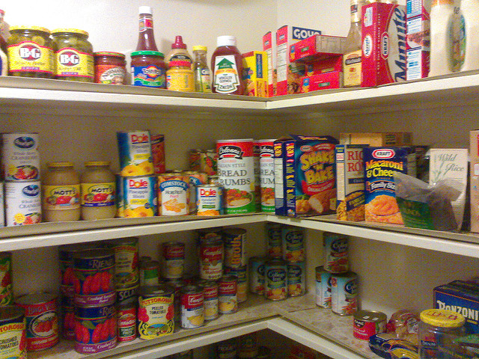  - [DATES OF DRIVE]  Stock The Shelves  for Siena Francis House  The Siena Francis House serves nearly 3,500 homeless men and women each year. Help stock the shelves with food, personal hygiene items, linens, paper items and more!  Bring your donations to [instructions on where to donate]  , Name |  | Donation Ideas  Canned Fruits and Vegetables (Large Cans)  Chips and treats for sack lunches  Bottled Water  Coffee  Coffee Creamer  Peanut butter  Jelly  Pasta  Pasta sauce  Pancake mix  Syrup  Ketchup  Mustard  Mayonnaise  Salad dressing  Tartar sauce  Vinegar  Cooking oil  Spices  Salt & Pepper packets  Sugar  Fruit Juice  Salsa  Instant potatoes  Rice  Flour  Soup (Large Cans)  Cleaning products  Toilet paper  Brown Paper Lunch Bags  Sandwich Bags  Deodorant  Shampoo  Conditioner  Bath Soap  Disposable Razors  Lip Balm  Pain Relievers

