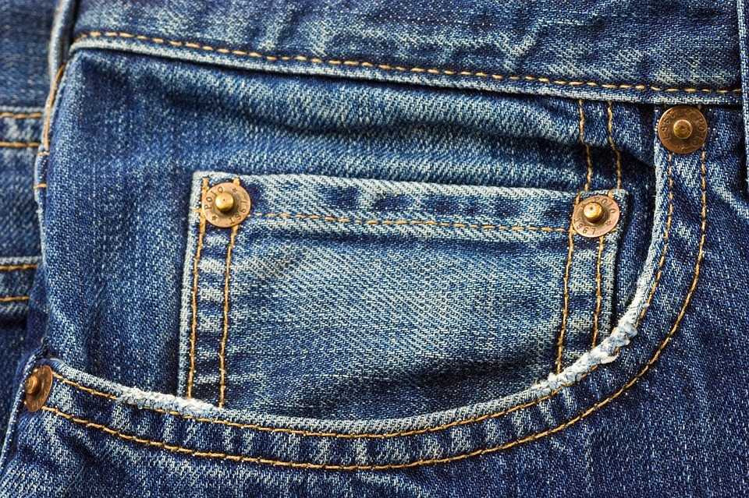



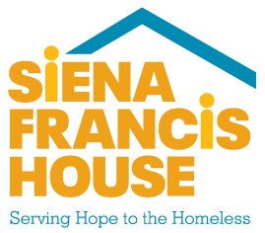
Suggested Items
[List items you would like to collect in your drive]
[ORGANIZATION NAME]
is collecting items for the homeless staying at Siena Francis House.

When: [DATES]

Where: [COLLECTION LOCATION]

Why: Siena Francis House serves homeless men and women in the Omaha metropolitan area each year, providing shelter, food, clothing and hope. In 2018, the organization provided emergency shelter to 3,435 people, and served 431,533 meals. Your donations make a real and meaningful difference in our community!
Help the Homeless!

